SAM Committee Meeting Agenda 5th Nov 2020

Those attending: - Callum Bremner, Rich Chubb, Kev Colmer, George Dupuis, Gina Herridge, Jez Martin, Lisa Parsons Tony Sauer, Graham Tulloch, Dan Wright, Ken Octan, Rob Bartlett, Alistair Gee, Roger Moffatt, Mel Adams,

Apologies: Nathan Beasley

Matters Arising from last Meeting:

- Nathan B to chase Urban Glow/ look at other options for the high vis bands for group rides. As agreed, previous meeting.
Still ongoing
- Nathan Update on the new TEC jackets

No update as Nathan not at meeting

Chair report

First of all is the new lockdown and the suspension of all training- decision taken on Saturday and by IAM on Monday.

Thanks to Mikayla our new publicity representative

New recruitment person George.

Thanks to Richard our under 30s spokes person

We have agreed, to have a green ride on the first Sunday of every month- this will continue from Dec

Group audit come- discussion with ADM- Nov 16th.

Score card

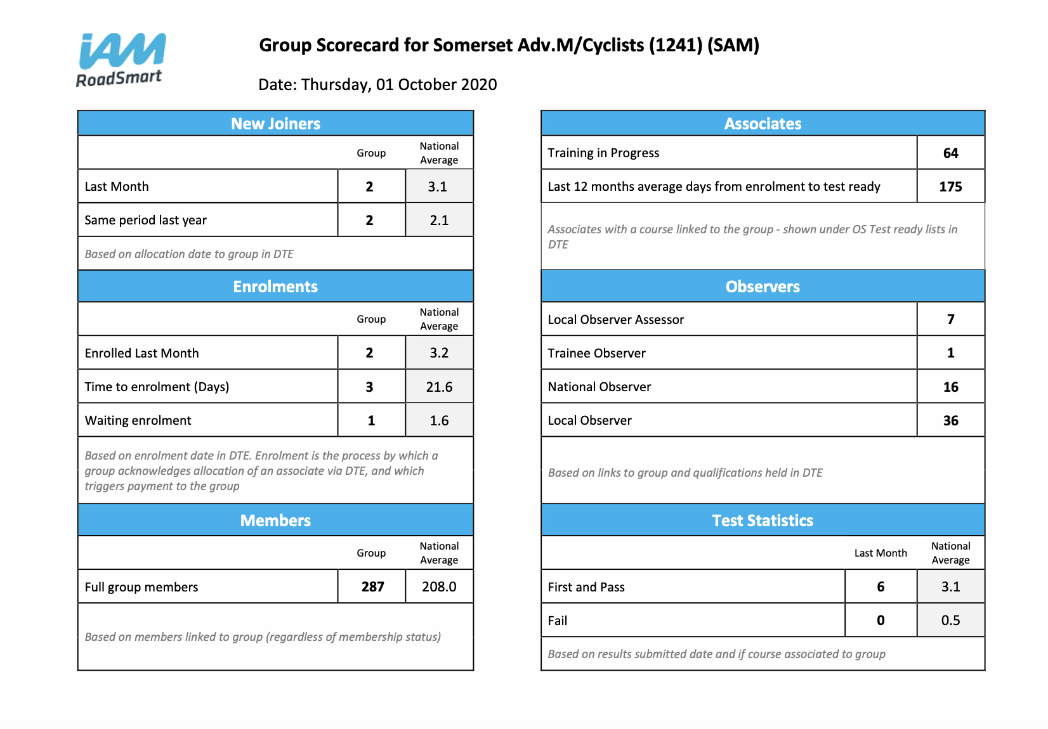
IAM RoadSmart

No real update as all being locked down. Apart from group audit and ASDM work, nothing is happening at the moment. Happy to take any feedback up the chain if needed.

Who gets inform sent to them? This was being sent on, but we have move to SAM website due to email issues.

I think the house keeping of website needs to be updated.

Kev to upload to website as inform is received. This was stopped due to email issues. But website is much easier.
Kev to email all members to let them that these will be uploaded.
Note- since the meeting I have not received a copy of this yet?

Merchandise

Email was sent to chair for facemasks. For observers. They were going to cost £6 each. Would this be an idea to put forward?

These masks had a carbon filter in them, so will be better than a buff.

Gina to email observers to see who would want one.

Buffs,

We ordered 1000 of these. Lisa would like to know how many we have given out. Have all members got any?
These have been sent to new members, Gina and Nath have been distributing. I take some with me.

Gina and Nathan and George have some. People can drop past to collect. Dave is picking up new members.

Have been given out at meetings ETC.

People who have joined in the last few years, and don’t go on many group rides will not have them. The original 1000 was for 2 SWPR and 500 for 1 per members. We need to make sure we don’t run out.

Lisa to put out Facebook post.

Recruitment

Roger today received new leaflets with Richard on them, to be distributed after lockdown.

Hoping to do some social media, so team will try and catch up at some point moving forward very soon.

Looking at sponsored adverts on Facebook, there is a cost that we need to look into. They cost about 10 pounds for approx. 48 hours. They would then see a pop up on their news feed, this is dependent of money and cost.
Budget would be needed!

Publicity and recruitment to go and make a plan for next meeting along with budget proposal.
Believe the last years budget was 1000k to give an indication to make plans.

Can we create SAM recruitment profile, suggested using SAM says. Jez to look into this to see if he can give George access.

Mikayla to work with Roger- green light to send out advert.

Gina proposed 1000 pounds recruitment budget for 2021 Graham T seconded.
Motion carried.

We do have Instagram account, but we need a good stream of content for these accounts to work.
Adam Evans has the info

Treasurer’s Report

Handover date 27th July 2020

July
IN: 603
OUT: 589.08
BAL: 13960.26

August
IN: 1214.24
OUT: 532.99
BAL: 14641.51

SQUARE PAYMENTS:
6/8/20 £32:66 - £33:50 Sale - Order 426
7/8/20 £28:27 - £29 Sale - Order 427
12/8/20 £28:27 - £29 Sale - Order 428
18/8/20 £28:27 - £29 Sale - Order 429
20/8/20 £28:27 - £29 Sale - Order 430

26/8/20 -£217:89
Refunds
£28:27 - £29 Sale - Order 342
£44:85 - £46 Sale - Order 304
£28:27 - £29 Sale - Order 367
£55:57 - £57 Sale - Order 330
£28:27 - £29 Sale - Order 354
£32:66 - £33:50 Sale - Order 355

SWPSR:
I think I will need a brief chat with Jez to get my head around this for reporting purposes.

TRAINING BIKE:
£245:64
Balance £246:80

RECRUITMENT:

PROMO 30:
William Blewett

----------------

September
IN: 678:00
OUT: 1410:15
BAL: 13909:36
Balance - Liabilities (SWPSR, Training Bike & Under 30): £7285:97

SQUARE PAYMENTS:
3/9/20 -£128:20
Refunds
£28:27 - £29 Sale - Order 313
£34:61 - £35:50 Sale - Order 245
£32:66 - £33:50 Sale - Order 302
£32:66 - £33:50 Sale - Order 310

SWPSR:
Balance: £5778:09 (worst case)

TRAINING BIKE:
Balance £246:80

RECRUITMENT:
No 2020 Budget
2019 Budget: £1500
Spend: £1635:53
Overspend: £135:53

PROMO 30:
No Change

Received Gross: £823:50
Received Net: £815:81
Out to Members: £225:00
Out to IAM: £1389:00

Received Total: £815:81
Out Total: £1614:00
Cost to SAM: £798:19
Current SAM liability: £598:50

------------

October
IN: 331:50
OUT: 856:66
BAL: 13384:20
Balance - Liabilities (SWPSR, Training Bike & Under 30): £6686:31

SQUARE PAYMENTS:
nil

SWPSR:
Balance: £5778:09 (worst case)

TRAINING BIKE:
Balance £246:80

RECRUITMENT:
No 2020 Budget
2019 Budget: £1500
Spend: £1635:53
Overspend: £135:53

PROMO 30:
Zsolt Pomaj

Received Gross: £898:00
Received Net: £890:31
Out to Members: £225:00
Out to IAM: £1538:00

Received Total: £890:31
Out Total: £1763:00
Cost to SAM: £872:69
Current SAM liability: £673

Membership

October was very poor, a few new members in Nov can’t join with IAM, new website should be live today.
One under 30 in November.

Full Chat

Final proof taking place, soft copy will go out tomorrow morning
Printers we will be contacting them tomorrow to make sure they are still working.

Events

Unfortunate these have been cancelled 6 rides planned for Dec.

Advertising

Nothing happening, moneys due in January. All up to date at the moment.

Observer Matters

15 Nos
30 LO

Everyone else is ready if we get associates

2 trainee observers- unofficial at the moment due to training restraints.
A couple looking for NO prep.

Incident Review none reported

None

Other Business
Next Meeting TBC

