SAM Committee Meeting Agenda 3Rd Sept 2020

Those attending: - Callum Bremner, Rich Chubb, Kev Colmer, George Dupuis, Gina Herridge, Jez Martin, Lisa Parsons Tony Sauer, Graham Tulloch, Dan Wright, Ken Octan, Rob Bartlett, Alistair Gee, Roger Moffatt, Mel Adams,

Apologies: Rab Lavender

Matters Arising from last Meeting:

- Nathan B to chase Urban Glow/ look at other options for the high vis bands for group rides. As agreed, previous meeting.
Still ongoing

- Nathan to get some more stickers produced. Box has been found, and we have loads- Closed.

- Nathan- Need some new flags- sorted with new Gasabo- Closed.

AP: Nathan would like some more TEC jackets. Nathan Proposed, Seconded name inaudible.

Chair report

- Position regarding Welsh Weekend, IAM happy for us to proceed. We need to regroup in Wales as the group size is bigger over there. So, we are going forward
- Callum report on Red rides, all went well and positive feedback.
- Publicity volunteer needed to take over from Mark Hill
- Richard Padfield- young ambassador about to pass test, need ideas on how to use publicity. Did this Facebook post drum up anything from Recruitment? We have had 2 responses.
- Post on Facebook, long standing member Rick and Matt, lifetime membership.
- Since May 30 new members join. We have had 2 new under 30’s.
- Liaison team, needs to be renewing
- Co-ord assist is Tony Saucer
- We have 72 associates
- Since end of lockdown we have 14 test passes. Requests for 43 taster rides already this year.

Score card

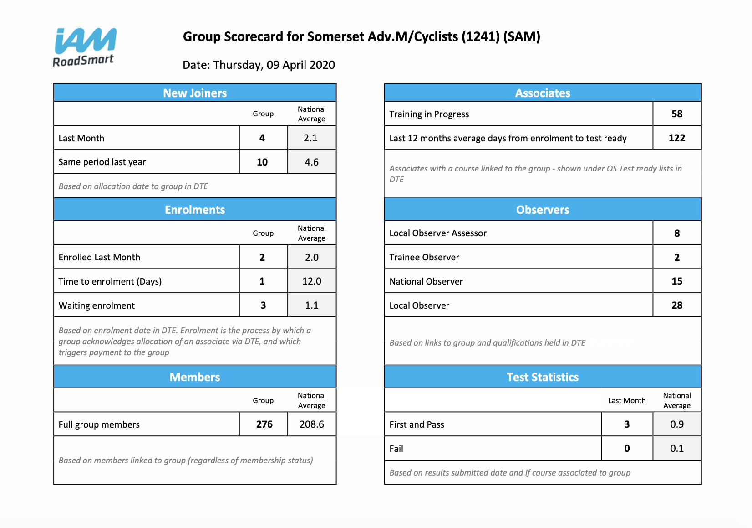
IAM RoadSmart

Not much to report. 3 skills days this year, feeling their way to make things COVID safe, all communications are looking to be virtually. Still upgrading software looking at Oct go live date. When there are website issues, we need to encourage people to pick up the phone, as someone will answer.

Merchandise

Orders are taking longer to come through, but supplier is getting up and running again. Nathan has some ideas, looking to revamp the online shop. Planning to try and drum up some more interest.
Gina to ask Observers again for anyone who does not have names Polo shirt again and pass to Nathan. Also, what about Volunteers.
Possibility of Merch at the slow skills day, New planned for Oct.

Recruitment

Still quite on public events front. Some bike nights are happening. Haynes breakfast ride in Nov and Dec, looking forward to getting back in there. We had first public event, and this went very well.

Treasurer’s Report

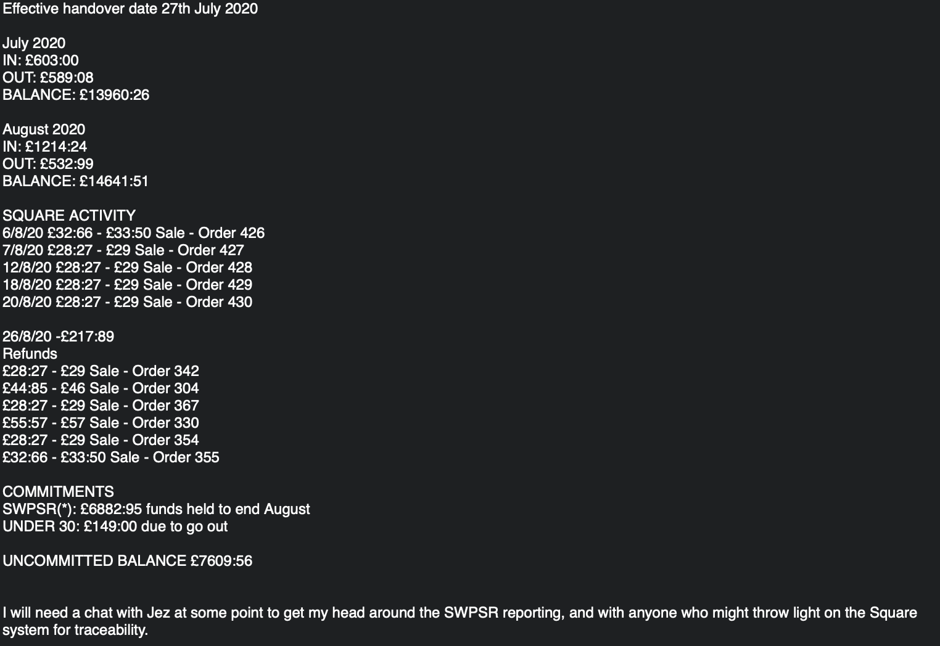

Membership

We have lost quite a few members in Aug; Dave has been perusing but there are some that are not re-joining. 2 new under 30’s.
Lisa to remind Dave of Hardship fund.

Full Chat

Sent out today, Printer low on work at the moment. Hoping to see this early next week. 250 copies have been printed again. Good varied contributions this time.

IT

Membership database is not showing huge churn, 206 full members. 71 associates. IT issues is no report showing new test passes or their observer. Jez to investigate.

Events

SWPR cancelled for this year, rescheduled for 10th April. Hall and catering have already booked. All entries contacted. Only 8 have asked for a refund. Vast majority of responses was very positive and supportive.
Slow riding event on the 4th of Oct arranged. As we have more notice, we can get more publicity.

Should we go ahead and cancel all events in Sept, and what about Oct C&T? General feeling is yes these should be cancelled.

Should we be looking at some longer-term planning for future events. A number of bubble rides on same date. Spread starts as well, Taunton- Yeovil.

Advertising

Not a lot to report. 2 advertising people have not paid subs, George Proposed to waive the fees for this year. Gina agrees this is correct, but we should formally tell them this is what we have done. We need to agree this before we can let them know.

George proposed this, Seconder Unknown. Voted and passed.

Observer Matters

Observer training has been continuing on an ad hoc basis, with both those who were able to attend the theory sessions and more recent test pass holders who are keen to go ahead being enrolled in practical training. In the absence of class room sessions we have moved to a mix of one to one practical training and shadowed runs where they can be arranged, to give new observers as much experience as possible. I’ve also been radio training some more observers, and happy to continue with any others who would like to use radios. I still have one Interphone Tour to issue, and half a dozen or so V1-1 monaural units. The order is in for new Hi Viz and patches.
14 NO’s 7 LOA’s 27 LO’s 9 TO’s officially, but only (I think) 5 actively pursuing training at present.
Planning to have and Observers’ meeting Friday 11th September 20.00 by Zoom as well as the scheduled one on 25th September.

Incident Review none reported

None

Other Business

Tony- SIB review process, what is the situation with this? Do we start now or hold off for later? Agreement to start this now from attendees at meeting.
Observers, can we have another comms channel for the observers to chat with each other. After some discussion it was agreed that we would set up a closed Facebook page for observers only.
Proposed by Gina, Seconded by, one No and one Abstention, vote passed.

On Behalf of Rab L- I had this down as being on Wednesday the 2nd, which is what is shown on the events page on the SAM website. Also, on the Events page is the rescheduled SWPSR 2020 being advertised for the 19th of September 2020. In my absence would you be so kind as to bring up with whoever that there is this duff information in the public domain.

Andy Hall- Am I able to lead a run, what's the current ride out situation? Complying with the new precautions of course.

Next Meeting TBC

