SAM Annual General Meeting held Virtually by Zoom Meeting Saturday 04/07/2020

Among those attending (non voting): all Associates and…….

Apologies: Tony Nares, Jules Cooper, Michael Collins

Minutes of the last AGM
Were unanimously accepted: Proposed, Gina Herridge, seconded Nathan Beasley.
One abstaining.

Matters Arising from last Meeting
None.

Chair Address:

Thanks for attending the AGM so this is valid as AGM decisions.
Farewell address, when I took over from Richard 2 years ago, we have 180 members approx. As it stands we have 269 members on our books. It has been slightly higher but with COVID we have had some fall by the wayside.
The other major achievement is the introduction of membership by portfolio. It was a great honour as a club to be asked to try this. So far, we have 6 members become full advance riders under this scheme. We currently have 2 people going thought the process. I think this is working very well, there have been a few slips along the way but feedback from the regional service delivery manager is very positive.

Some thankyou to make;

Everyone who has acted in official roles through my tenure, you have all been a great support to me. It has been an honour and a privilege to be your chair

Special thanks to Alistair as treasure, as he has allowed me to send some money to support our aims and road safety.
Special thanks to Kev for being a very supportive secretary and tonight’s continuity candidate as myself and Alistair are stepping down.

Special thanks to Lisa Parsons who has been membership secretary during my time as chair, and also took on associate coordinator role when we lost Paul Dyer approx. June last year.
Thanks to Paul for all he did as Associate coordination.

Thanks to Dave Parker for stepping up as membership secretary.

Thanks to members for support and understanding during lockdown. I would never has seen making the decision as Chair to stop all activities and this was possibly the hardest decision I ever had to make as Chair.

As we start to exit lockdown it now feels right to hand over to our new leader to lead us out of this.

Treasurer Report:

As you are aware, I am stepping down as Treasure at this AGM. I would like to thank everyone who has helped me run the treasury of the club.

Current Account £14241.34
Petty Cash £10.00
None outstanding

Total £14251.34

Made up of

Restricted bike fund £492.44
Under 30s promotion £524
Promotions budget £248.10
Training budget £1000.00

SWPR
Income £6849.45
Entry refunds £212.66
Outgoings £892.20

Rally Funds £5744.59

General Funds £6242.21

Over the past year we have donated £806 to St Margert’s Hospice.

Last year’s accounts for approval.

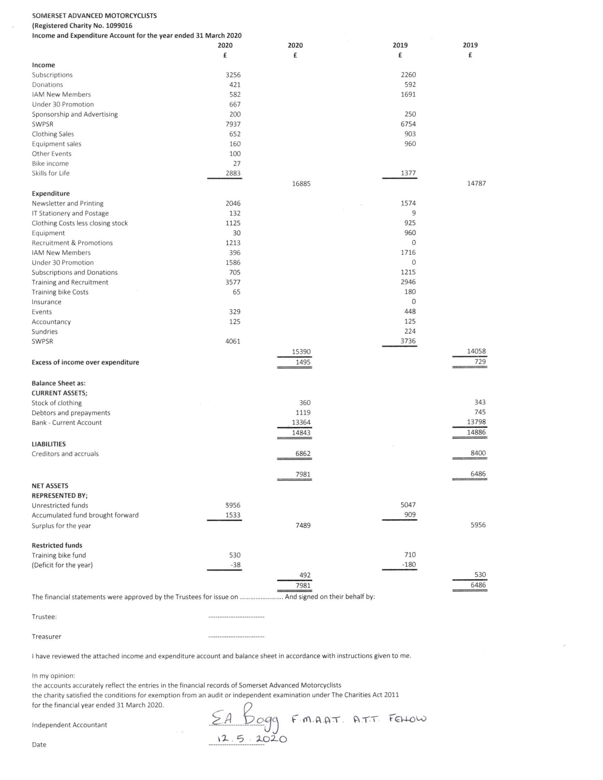

Election of incoming committee:

Chair: Lisa Parsons.
Proposed- Gina Herridge
Seconded- Kev Colmer
Agreed

Secretary: Kevin Colmer.
Proposed- Jez martin
Seconded- Gina Herridge
Agreed

Treasurer: Rab lavender
Proposed- Gina Herridge
Seconded- Graham Tulloch
Agreed

Other committee members have agreed to take over or continue with specific responsibilities for the coming year, named (not elected) as:

Gina Herridge, Chief Observer/Observer Training Coordinator and Assisting Newsletter Editor
Dave Parker, Membership Secretary
Graham Tulloch, Newsletter Editor
Jez Martin, Events Secretary and IT Lead
Georges Dupuis, Advertising Secretary
Vacant, Publicity Secretary
Ben Everard, Website
Dave Parker, Membership Secretary
Lisa Parsons Observer coordinator
Roger Moffatt Taster Ride Co-ordinator
Andy Hall Deputy Secretary
Agreed

Measuring Somerset Competition 2019-2020.

Winner was Trevor Watts- Aware was delivered.

Our Unsung Hero

Votes were as follows
People with One vote
David Potter
Helen Moriarty
Peter Herridge
Gina Herridge

People with Two votes
Mark Livingstone
Dan Wright
Ian Frazer
Graham Tulloch
Dale Stote
Steve Schlemmer

People with Three votes
Lisa Parsons
Roger Moffatt

People with four votes
Jez Martin

Winner
Nathan Beesley

New Chair Address

Thanks to the previous Chair, Jez for all you work.
Thanks to Alistair and thanks to Rab for taking over,
Also, personal thanks to Dave Parker for taking over as membership secretary.

Moving forward I want to keep the club friendly while growing in size. The funds are healthy so some money to spend. I will also be looking to fill some vacancies; Publicity roll will be vacant at the end of the SWPR and we are all looking for fresh faces.
A big thanks to all our observers.

SWPR

This has been postponed to Sept 19th. We have only had about 6 or 7 people asking for refunds out of about 200 entrants. All have been loyal and looking forward to September. Planning continues as normal. Closer to the time we will be able to see the COVID situation at the time and can make any adjustments needed at that point.
This brings in a lot of funds we can’t spent this yet, but we know there are going to be a good intake of profits once the rally is completed.

AOB
None

The date for the 2021 AGM will be set by our events coordinator.

