SAM Committee Meeting Agenda 27th May 2020

Those attending: - Callum Bremner, Rich Chubb, Kev Colmer, George Dupuis, Gina Herridge, Rab Lavender, Jez Martin, Lisa Parsons Tony Sauer, Graham Tulloch, Dan Wright, Ken Octon

Apologies: Rob Bartlett, Alistair Gee, Roger Moffatt, Mel Adams,

Matters Arising from last Meeting:

- Nathan B to chase Urban Glow/ look at other options for the high vis bands for group rides. As agreed, previous meeting.
Chased, and trying different armbands, work in progress.
NB brought samples trading off quality and expense. Would need more than 30, but also need to think about logistics of handing them on to next ride leader. ONGOING

- Nathan to get some more stickers produced. Can order 650 for £98. Action NB
On going

- Nathan- Need some new flags, new modern color and that can fit on a bike. Nothing has been ordered as yet. Ian Fraser found some more suitable flags, ONGOING.

Chair report

We have all been in lockdown, we have had small committee meetings to try keep things ticking over. This is where Observer training and Zoom training meetings have come from.
IAM RS have started to make noise as to how we will move forward when lockdown is lifted, not real news but safety is key.
Gina has written out to observers to start to make contact for getting started again.
SWPR we have only had 6 people to reimburse out of the 200 or so entrants.

Score card

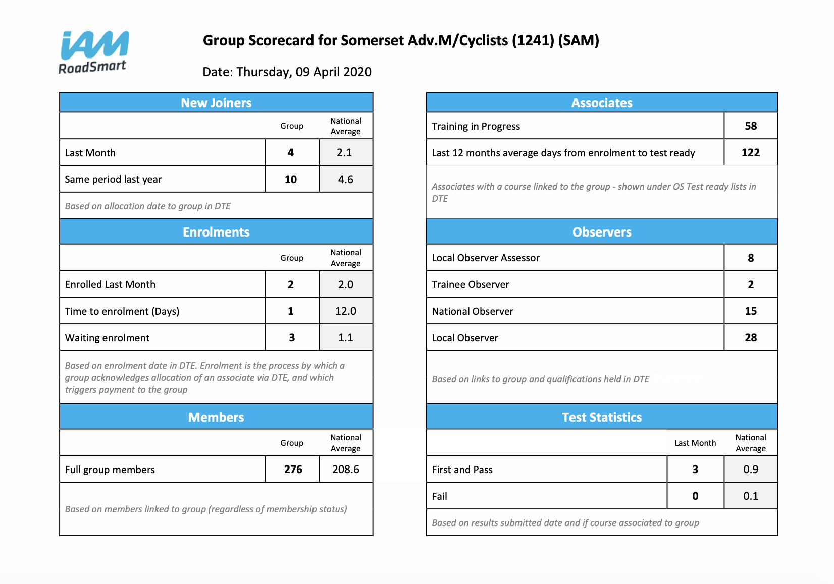

This is 9th of April so numbers low next scorecard expected to look worse than this.
Also, 7 Taster rides booked for when we are back in action

AGM 2020

AGM will not be able to take place in the current climate, so we will need to go for a virtual approach.
Date of 4/5th July or 11/12th July, are provisional dates. Suggest we work to the 4th July and we can then have a fall back a week if needed.

Review to make are all non-elected officials captured and correct for AGM

Gina Herridge, Chief Observer/Observer Training Coordinator and Assisting Newsletter Editor
Dave Parker, Membership Secretary
Graham Tulloch, Newsletter Editor
Jez Martin, Events Secretary and IT Lead
Georges Dupuis, Advertising Secretary
Vacant, Publicity Secretary
Ben Everard, Website
Lisa Parsons Observer coordinator
Rick Chubb, MAG representative
Roger Moffatt Taster Ride Co-ordinator
Andy Hall Deputy Secretary

Sanity check completed by all on Zoom Meeting and not errors highlighted, to be block agreed at AGM

COVID-19 Impact on Club and plans

A few things to be thinking about. How can we be doing observing in a safe way? Also, what systems can we put in pack for group rides. Will 20-30 people on a ride be acceptable, but also expect to have a large uptake.
Too large a group will give bad publicity even if social distancing is done correctly. We still believe it will be some time before we will be able to do group rides.

IAM RS providing some guidance that will be added to the website, but at the moment this is all not to take place.

Trustees Review

Current info registered with Charity Commission; any amendments additions needed?

JM- Is there a formal process to nominate the Trustees? Their role is to make sure we are operating in line with the charity commission.

GH- When set SAM up as opposed to car/bike group, some needed to step forward to make this happen, Club Officers have a requirement to be a Trustee, Treasurer to be added.

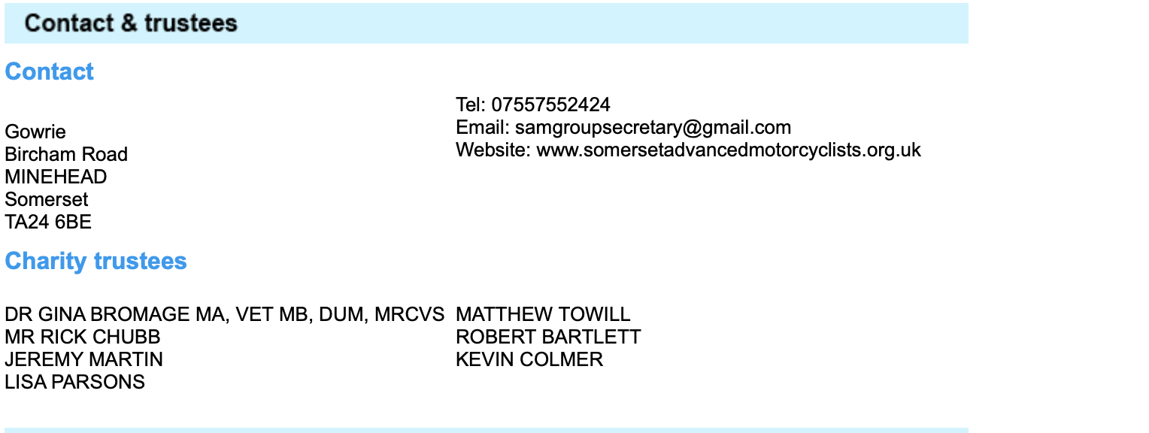

Trustees are reviewed each year for Charity Commission return completed by Sec.

RL- All relates to the governing document, One reg with charity commission. Sec to send to RL.

IAM RoadSmart

Already discussed most things that have touched us. Mainly waiting till we can get back observing. Gina asked for update on group survey. Jez has info and will get completed by the end of the week.
Amanda Smith has sent survey to ask all groups what activities they are completing and how we plan to move forward when lock down lifted. So they can share best practice.
There should be a new computer system at the end of Aug, which will keep the records a lot cleaner.
New CEO who is generally seen as a good thing. IAM have also asked for examiner availability post COVID.

Merchandise

Nathan not present. No update.

Recruitment

DW- recruitment team had meeting in Jan, but other meetings have been halted by COVID. When IAM shed more light on activates moving forward then will look to hold a meeting then.

Post meeting note: Recruitment Team meeting held 3.6.20 by Zoom

Treasurer’s Report

Treasurer’s Report 27 May 2020

Current Account 13558.24
Petty Cash Promotions Float 10.00
13568.24

Less
Cheques Issued 0.00
Accounts Payable 0.00
13568.24

Restricted Trg. Bike Funds 492.44

Under 30 Promo 450.00

Promotions Budget Remaining 248.10

SWPSR 6804.60
Less Refunds 212.66 6591.94

Training 1000.00

General Funds 4785.76
13568.24

Promo 30 £1240.00 paid out to IAM. £450 due members when they pass. Three associates have passed and been refunded £75.00 each.
Total donated to St. Margaret’s Hospice £806.00
SWPSR Hall paid for £250. Deposit for food paid £200

Membership

LP- Nothing to report, role is being handed over to Dave Parker but until then I will just keep doing what I am doing.

68 Current Ass
45- 1st year
23 carried over

204 Full
2 Friends
274 Total

3 new pass and 10 new members in last quarter.

Full Chat

Spring version has gone out and Graham is working on the Lockdown Special. Ask for pictures request in minutes removed as no one sends any in anyway.
All articles to be submitted with photos, or it will not be included.

IT

JM- Have been working on database. Work in progress with new functions being added like attachments to email and Committee distribution list. Hoping this will be fully functional as needed now.
Web team to discuss move of website to AWS hosting, as pre previously agreed with committee.

Advertising

George not taken handover yet, so no update.

Observer Matters

GH- we have one observer who may not be able to carry on as he has no income during lockdown.

Gian Proposed- we offer to reimburse fuel expenses for observers who have been having issues due to COVID.
Jez Martin Seconded.
No Objections or abstentions.
Vote carried.

GH- Zoom meetings for observer training every Tuesday next week is assessing a ride. Mainly for new observers, but open to all. Observers polled for training post lockdown, a few asked for fast track to NO or LO.

Communication

Mark not attending so no update.

KO- Given the current status, lots of people are desperate to get out on bikes. We should be publishing quite a lot on SAM Facebook, as very little published and over 1000 followers. Maybe some info on riding safe and advanced riding training. Publicity takes a long time to get through, so may be a good time to get the idea in people’s heads.

Incident Review none reported

None

Other Business

RL- Maybe we could have some posts on Facebook about the different dangers on the roads now with more wildlife ETC.
DW- maybe we could do a video post, such as the bikerdown group have done. Dan to sort video. Any ideas so SAMrecruitmentteam@gmail.com

Next Meeting TBC

