SAM Committee Meeting Agenda 4th March 2020

Those attending: Jez Martin, Gina Herridge, Rob Bartlett, Matt Towill, Jim Donnelly, Roger Moffat, Lisa Parsons, Mark Hill, Tony Sauer, Nigel Gillard, Peter Herridge, Dan Wright, Georges Dupuis, Richard Pearse, Alistair Gee, Callum Bremner, Nathan Beesley, RAB Lavender, Graham Tulloch.

Apologies: Kev Colmer Andy Spiers. Andy Hall.

Start: 19.31

Matters Arising from last Meeting:

- Jez- working on a new database and ability to send emails to all members in one go.
COMPLETE: Database is now up and running.

- Nathan B to chase Urban Glow/ look at other options for the high vis bands for group rides. As agreed previous meeting.
Chased, and trying different armbands, work in progress.
NB brought samples trading off quality and expense. Would need more than 30, but also need to think about logistics of handing them on to next ride leader. ONGOING

- CHIRP now established with advisory board of suitably experienced members, note to go into next Full Chat. ACTION Tony Sauer

- Jez proposal to fund Masters for Observers at last meeting, Gina to see what uptake would be and committee to think for discussion and decision at next meeting. Gina to ask observers Who would be interested in Masters subsidy and How much money they would like towards it. Ongoing POST MEETING NOTE: Poll of observers found about 2/3 would appreciate help with Masters costs (£150 most common suggestion), others not feel that it’s a good way to use club funds. Some observers have not responded.

- CB proposes an amount allocated each year as a training fund. JD second. JM propose £1,000 for this year, any member can bid and Training Team Leads decide if bids are appropriate. Carried unanimously.

- Nathan to get some more stickers produced. Can order 650 for £98. Action NB
On going

- Nathan- Need some new flags, new modern color and that can fit on a bike. Nothing has been ordered as yet. Ian Fraser found some more suitable flags, ONGOING.

Chair report

Went to regional meeting, (“coffee morning”) to share best practice. From previous Breakfast meetings we learn: No more marketing discounts to £99 - can use club funds if we want to subsidies ARC sales. ACTION PH to contact Amanda Smith to see if taster discount still applies.
New IT system from IAMRS due to start in August. Should have capability to replace group databases.
Observers will be required to submit runsheets online to IAMRS.
IAMRS are aware that there may be pushback from observers.
Succession planning - no new insights; other clubs generally in worse shape than ours for succession.
AGM 21/3/20 Lamb and Lion Chips ordered! Dean from Helmet City speaking, arranged by LP.
Alistair standing down, need a full member to be Treasurer. Chair urges members to help find a volunteer.
SWPSR and Covid 19. 166 entries at last count. Proceeding as planned for now.
Need new Advertising sec at AGM, Andy Spiers standing down. Chair recorded thanks to Andy Spiers for service so far.
ACTION JM to email membership for further volunteers.

Score card

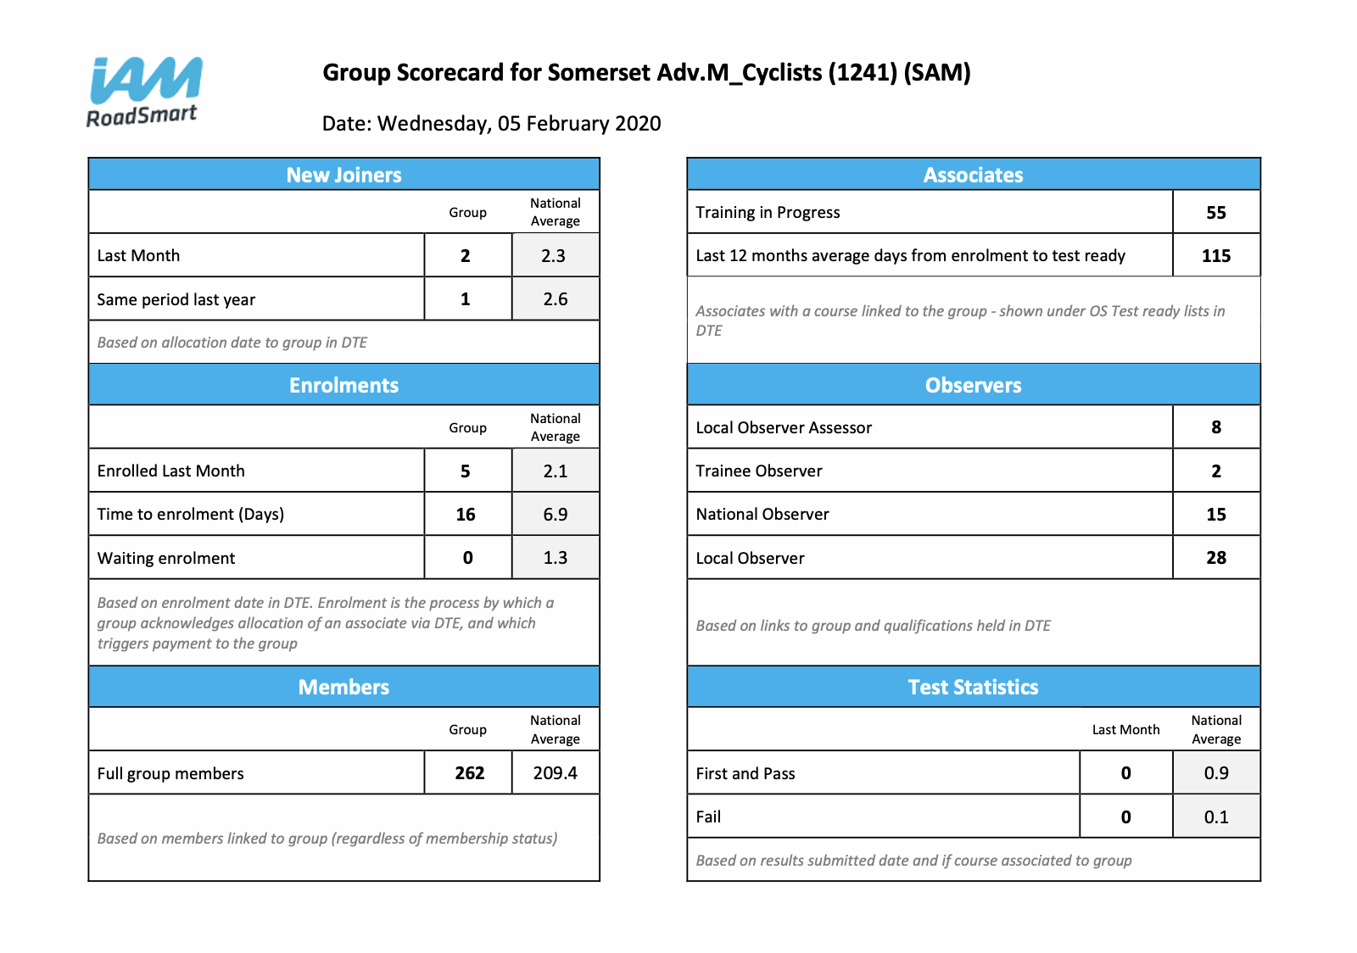

IAM RoadSmart – offering the chance to buy A Frames for posters at £35 each Ours still in good condition and don’t need any more.
New Trustees appointed and announced: Nick Lomas, Nick Stein, John Jenkins, Jeff Wilcox, Stuart Donald.

Merchandise - going well, establishing on line shop ongoing. Necktubes in IAM and SAM logos to be ordered and will be giveaway with SWPSR. Members and new joiners will be issued with one.

Recruitment – meeting held at SJP on 30th January. Notes inserted here:

RECRUITMENT TEAM MEETING 30/1/20

Present: Nathan Beesley, Roger Moffat, Gina Herridge, Peter Herridge. Apologies Ian and Pam Fraser.

Events - Neill Sedgewick has a list of events he supports at which we could also attend. PH points out that publicity as important as the event itself, so important to get the message out if we are going to be present. We need to liaise with Publicity Team and be discerning about which events we attend, since they have to be manned by someone. ACTION GB circulate list to SAM members to see if any want to attend on SAM’s behalf. NB to check that NS ok with that. [Post meeting note; he is, but GB not yet circulated list to membership]

- Haynes - 12 events to cover. Almost all 3rd Sunday of month. RM has reduced number of rides to 3 all at 10:00 with waiting list used to “stack” other candidates. Need two people to meet and greet, plus one or two to take out tasters. Roger has closed bookings on Thursday night and stands down observers who are not required. Suggestion PH to invite people to commit to one or two Haynes a year, to free up others on pre-notified weekends. Acknowledge that some have indicated a willingness to help, and that this is the next step. Do via Doodle Poll or Three Rings. Need a system for handing over kit: Two feather flags, flyers, laminate for front of bike, doc’s dec’s, business cards, Z Cards. RM to ask Haynes if will mention our presence on their website.

- Bristol Classic Bike Show all in hand.

- Dedicated Recruitment Day/Taster Ride Event - eg at Cartgate on a weekend. Discussed feasibility, but thought that Haynes and Slow riding may be adequate - if better publicised - Liaise with Mark Hill to get message out.
- Total Triumph doing the Mossman run in support of St Margaret’s and Blood bikes NB to see if we could/should be there too. 5th July 2020.

- Demarcation between Recruitment, Social Media, Tasters, Slow Riding event - can offer tasters at Slow riding for those waiting, need to supply appropriate route for non local observers at all taster events, make sure that we can sell ARC’s (card machine). ACTION GB tell observers so are ready to do tasters from there as well - liaise first with Mark Livingstone.

- Under 30s Discount - send rebate form with welcome email to Under 30’s so they know that they should claim it when passing a test. GB contact Assoc. Coordinator.

- Equipment - Gazebo - should be delivered in March.
            - Flyers? ACTION NB to check through stock and cull useless ones, create a list of new ones to order from IAM.
            - Anything else?
            - Feather flags - Nathan to contact Ian to see where we are with that.
- New RT members - Full Chat and membership email. ACTION GB
- Publicity - Is/are our Facebook page(s) business pages? GB CHECK WITH MARK.
- ACTION GB inform observers that IAM will print business cards for us FOC. NB to send link to GB.

From Memb. Sec:
Some very positive and surprising numbers for you.

96 new members in 2019 (this inc new full members from other clubs)
Mark Hill can post to non members page if anyone lets him know what they want put there.

TREASURER’S REPORT. [TO BE ADDED BY ALISTAIR]

Treasurer’s Report 04 March 2020

Current Account 14092.85
Petty Cash Promotions Float 10.00
14102.85

Less
Cheques Issued 0.00
Accounts Payable 0.00
14102.85

Restricted Trg. Bike Funds 530.78

Under 30 Promo 450.00

Promotions Budget Remaining 925.60

SWPSR 6088.54

General Funds 6107.93
14102.85

Balance = £0000.00

Promo 30 £1091.00 paid out to IAM. £450 due members when they pass. Two associates have passed and been refunded £75.00 each.
£265.00 taken to St. Margaret’s Hospice total so far £711.00.
SWPSR Hall paid for £250. Deposit for food paid £200

Under 30’s rebate only paid out twice, there is one overdue, not yet claimed.

Membership
278 total members, assoc’s 69, 58 new and 11 carried over. Full members 207, 2 friends. 17 new members in last quarter.

Full Chat

Graham made a request for more photos and words!
Next Deadline is April 15th 2020.
Rick Chubb’s MAG correspondence included and approved of.
Generally GT includes all new contributors’ stuff as a priority. Very close to max weight at 56 pages. Going to refresh code of conduct etc.

IT Database now giving facility to email different groups of members straight from the database itself. Meeting with IT team pending but should approve moving hosting server across to AWS so will be in same places as database.

Advertising Andy Spiers standing down but all other advertisers have paid. Morgans will probably not continue.

Observer Matters
OBSERVER TRAINING REPORT 4/3/20

All four theory sessions now delivered. Still awaiting ability to cleanse DB to add the new trainees, but think there will be about 15. 10 signed up last Wednesday, there are 3 correspondence ones, and a couple who couldn’t come on Weds.
Having a bigger team to deliver the theory sessions has improved the quality, very big thanks to Martin Surrey, Rob Bartlett, Lisa Parsons, Peter Herridge, Jez Martin, Callum Bremner, Georges Dupuis, and Jim Donnelly.

Two more observers (Dave Slocombe and Andy Phillips) are now radio trained.

First practical session is on 28th March, second on 16th May. Four have signed up for the IGTT.

I have one NO and 1 radio training candidate pending.

Registration of LO candidates – take a chance or wait in case some are not going to make it? CB proposed later registration of LO’s so that fewer will fall by the wayside. Seconded JM. Carried unanimously.

Question: Can’t we draw locations of observers from members’ data for observers? JM can sort

Communication Mark Hill,
4 Rally communications so far. Also promoting under 30’s rebate, and Slow Riding. ACTION JM liaise with Kathy Horniblow to see if can get some images to go into Adventure Bike Rider after event.

Incident Review none reported.

Other Business -
Ad hoc rides have been publicised on FB SAM members’ page. GT proposing that we make it clear that the ride is either an official SAM ride with briefing Grading etc, or unofficial ride, not covered by IAM insurance. Seconded JD. Carried unanimously.
ACTION – WHO?

RP design for Rally mug? NB ongoing, nearly complete. May also have flags.

TS how about club buying some action cameras for observer use? ACTION TS to scope out what is available and what would cost.

GB Can Obs. Coordinator to include membership number on notification to observers so doc’s dec’s can be completed properly? Response in affirmative from ObsCo.

GB will SAM underwrite non recoverable costs of IGTT if has to be cancelled? Proposed GB seconded GT carried unanimously.

Closed 21.29.

