SAM Committee Meeting Minutes,

7th Jan 2020

Those attending: Alistair Gee, Kev Colmer, Rob Lavender, Lisa Parsons, Mark Hill, George Dupuis, Nathan Beesley, Jez Martin, Steve Schlemmer, Richard Pearse, Gina Herridge, Andy Hall, Rob Bartlett, Peter Herridge, John Hooper, Wayne Timbrell, David Hanks, Tony Sauer, Dave Parker, Dan Wright,

Apologies: Graham Tulloch, Adam Evans, Paul Crummay, Callum Bremner, Jim Donnelly, Tony Hamilton, Tony Nares, Andy Spires,

Start 19.43

Matters Arising from last Meeting:

Review Action

- Jez- working on a new database and ability to send emails to all members in one go.
Ongoing,
Database ready to go. Now in test stage, waiting feedback from players who use. Should be able to swap. All users will agree sheet data is accurate. Then will stop work on google and cut across to new database, this will take 4 hours.

- Nathan B to chase Urban Glow/ look at other options for the high vis arm bands for group rides. As agreed previous meeting.
Chased, and trying different armbands, working in progress- ongoing

- Gina H- Observer training and some form of IGGT weekend for SAM only. Gina to see what uptake would be like and do some research of costs ETC.

- Polled observers and just about all would be happy with IGGT style if dates suitable, about 15 would be interested in a weekend away. Two nights in Wales or Devon would cost around £3,500 for 21 attendees.

Next step to look for a date that most people can make.

Gina H- to look at Observer pack for new qualified observers. What would this have in it, costs ETC. Base list still with Gina, but any other ideas to be passed over- closed
Contents for new observer pack: Highway Code (£2.25 on Amazon, but can also download free to smartphone) Roadcraft (£12 on Amazon but new edition in progress)Doc’s Dec’s, debrief forms, briefing/debriefing prompt card, note book, pens and folder £15. High viz Urban Glow RoadStar ?£70.

- Jez- to think about who would be good for the peer to peer review of feedback from Tony’s idea (see observer sectionStill Ongoing. As 2x Dep for training team and chief observers. They would be ideal. Tony would like more than 2 in the review board, and we will look for more people. Tony to discuss with these people directly.
Should this be Observers. Gina to ask observers if they are interested and see what responses we get. Gina to work with tony and provide workable plan.
- Gina action to ask observers ongoing! Post meeting note: ACTION ONGOING TS and GH sending out invitations to observers to act as reviewers with explanation of how scheme will operate.

- Jez proposal to fund Masters for Observers at last meeting, Gina to see what uptake would be and committee to think for discussion and decision at next meeting.

Gina to ask observes- ongoing. Who would be interested and How much money they would like towards it. – Ongoing POST MEETING NOTE: Poll of observers found about 2/3 would appreciate help with Masters costs, others not feel that it’s a good way to use club funds. Some observers have not responded.

- Dave P- New idea of riding in 4s setting off at 5 min intervals. General consensus to try something new, Action point to DAVE. Maybe add to current green rides, Dave to look at dates with Jez.

Scheduled for Feb! May be too soon in Feb but willing to do something later on in the year. Dave P to look at events list and select a date and then advertise this to the membership, closed .

- Nathan to get some more stickers produced.

On going

Chair report

Great to see so many people at the meetings, same as last time. Not a lot since last meeting Christmas and new year ETC, first ride of the year was very successful Thanks to Gina and Pete. Trickle of new members over Christmas, membership sec has been allocating. First C and T will be on Sat on braking.
A number of chair meetings, Jez and Lisa to attend Exeter to rep the club.

Informal IAM motorcycle group chair’s meeting, delayed so that regional meetings have been attended first. 1ST sat in Feb

SWPR planning started, tickets on sale 60 or so sold so far.

Publicity has now started again; we now have coms lead Mark Hill. Mark will draft and Tom Moore will post out into the clubs. Events that need to be promoted reach out to Mark.

Score Card Status
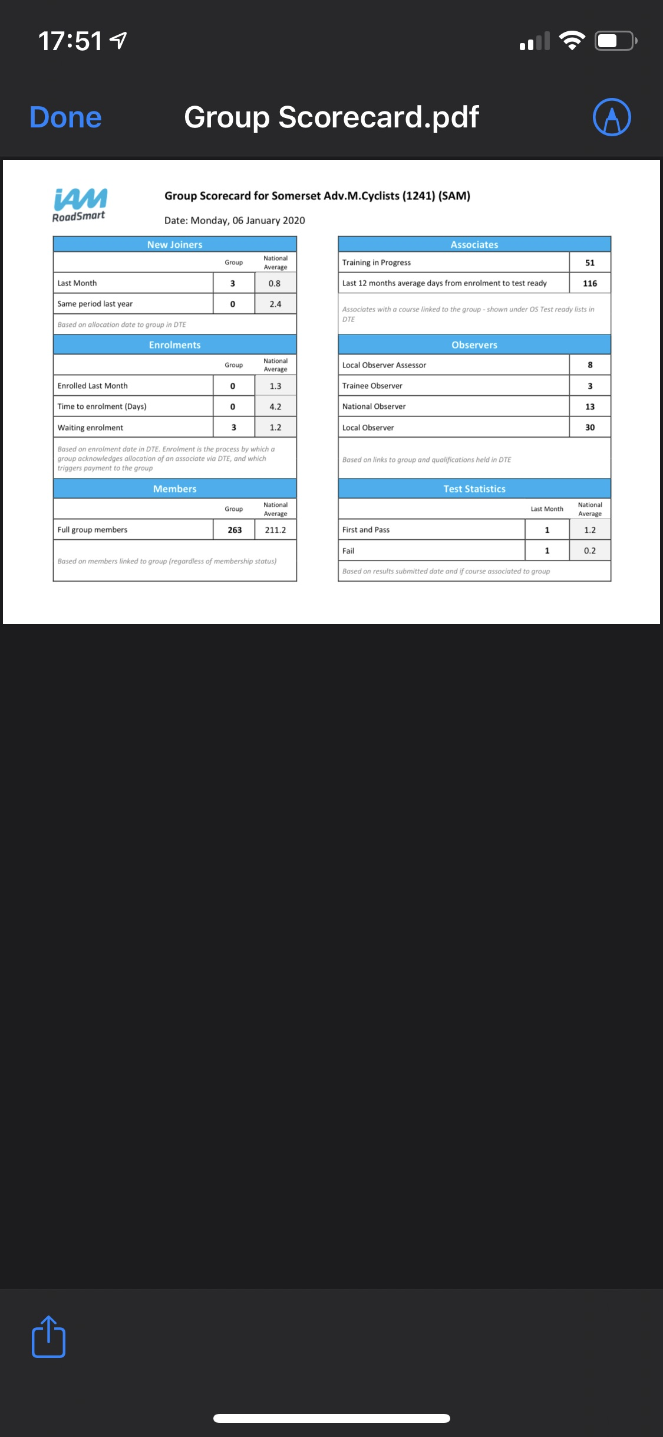

IAM RoadSmart

No real update as nothing happened since last committee meetings,

Treasurer report
07 January 2020

Current Account 10625.04
Petty Cash Promotions Float 10.00
10635.04

Less
Cheques Issued 0.00
Accounts Payable 200.00
10435.04

Restricted Trg. Bike Funds 530.78

Under 30 Promo 450.00

SWPSR 1874.75

General Funds 7579.51
10435.04

Balance = £0000.00

Promo 30 £1091.00 paid out to IAM. £450 due members when they pass. Two associates have passed and been refunded £75.00 each.

£200.00 taken to St. Margaret’s Hospice total so far £446.00.

£1500 for Promotions

SWPSR
Only paid £25.00 for hall when is rest due? PH said not yet been asked for it

Merchandise

All going well some more stock needed to be topped up.

SWPR merch, email about mugs, quote for 250 asked
Also talking about neck tubes, Nathan waiting for designs to come back, price will vary on how many we purchase.

Suggestion mugs should be SWPR and neck tubes should be SAM then can be stock item. Gina suggested IAM ROADSMART should be on this as well.

Gazebo only £400 spent, from budget. LED lighting may be needed, cost approx. £150. And maybe some other spotlights. Classic bike show pitch is free but power costs £50

Need some new flags, new modern color and that can fit on a bike. Nothing has been ordered as yet. Nathan to chase-

Recruitment

Handed over to Nathan, classic bike show will be next big event. Steady trickle of new members has meant that there has been no huge drive. Maybe some more assistance to Haynes which has been ongoing.
Nathan to speak to Roger ref a Rota, there were some volunteers that were not used and not contacted. This needs to be run as a team, rather than leaving for Roger, to formalize the arrangements.

Membership

Total membership 268
3 new associates in December
Total associates 61

1st year 48
Carry 13

Of the last 6 associates, 5 opting for MBP-

Observer CO-ord

All is going well, LOs we have 28
Loading is
3 observer without associates
29 observer with 1 associates
5 observer with 2 associates
1 observer with 3 associates

MBPs to date 5 in training, 2 successful qualifications.

Full Chat

- Graham made a request for more photos and words!
15th Jan is cut off for articles.
Thanks to those that have sent in already

Nath to print a list a hard copy of events lists to be added to full chat.

IT

Currently website is hosted on fastnet, but database is hosted on another host AWS, should we move all to AWS so all is in one place.
Webmaster will have no issues as hosted on own server and then re-directed.

Fastnet acc currently in Peter Hs name.

Advertising

Under control.
Next round of subs collected this month.

Observer

NO and LOA Status

Contact ID | Observer Name | IMI Local Assessor Bike | Last Completed Course | Last Completed Date | Next Assessment Date | Membership Status
00328713 | Robert Bartlett | Yes | Internal NO LOA Observation QA Motorcycle | 09/11/2016 | 09/11/2019 | Current
00506443 | Lisa Parsons | Yes | IMI National Observer Programme Motorcycle | 09/09/2017 | 09/09/2020 | Current
00386893 | Ian Wilson |  | IMI National Observer Programme Motorcycle | 21/11/2015 | 21/11/2020 | Current
00312529 | Peter Herridge |  | Internal NO LOA Observation QA Motorcycle | 14/03/2016 | 14/03/2021 | Current
00499591 | Callum Bremner | Yes | IMI National Observer Programme Motorcycle | 29/03/2018 | 29/03/2021 | Current
00459960 | Jeremy Martin | Yes | Internal LOA Observation QA Motorcycle | 15/04/2018 | 15/04/2021 | Current
00328421 | James Donnelly | Yes | IMI National Observer Programme Motorcycle | 30/05/2018 | 30/05/2021 | Current
00243584 | Graham Tulloch |  | IMI National Observer Programme Motorcycle | 19/06/2016 | 19/06/2021 | Current
00189863 | Gina Herridge | Yes | Internal LOA Observation QA Motorcycle | 09/04/2019 | 09/04/2022 | Current
00389047 | Hugh Beamish | Yes | IMI National Observer Programme Motorcycle | 14/04/2019 | 14/04/2022 | Current
00524129 | Richard Sutton |  | IMI National Observer Programme Motorcycle | 04/12/2018 | 04/12/2023 | Current
00613264 | Steve Williams |  | IMI National Observer Programme Motorcycle | 14/04/2019 | 14/04/2024 | Current
00413095 | Martin Surrey |  | IMI National Observer Programme Motorcycle | 14/11/2019 | 14/11/2024 | Current

Season on NO prep, 3 people through NO since last meeting. (Peter Bayliss and Andy Phillips, not included in above chart)None have asked to be LOAs but all could if they wanted. No further assessment needed.

4 people someway down track and quite like for current Nos to step up and prep new Nos.

Need to expand currently No numbers.
Callum taken over prep for new observers. Rough numbers of about 10 so far.

Incident Review

None

Other Business

Richard Pearse, Is Graham doing the maps for SWPR, Graham is able to do these.
Can manual entries be entered onto the shop, Jez to look into

Andy Hall, Did we consider a C and T on Night riding, this may be needed to look at for the future, as too late for this year. In addition, maybe added into a current session, such as cornering. Should be at the beginning of the C and T session Nov or Dec time so max effect.

Rob L What are the rights around using the logo, can we add to website? In contacts and suppliers. Gina, are we ok with logo being used in racing image?
Jez, no problems at all and agreed.

Mark,
Wants to build a plan for the year of proactive sending across year. Would the best way be to contact org of the events.
Really we only advertised few everts
Classic bike show
SWPR
Haynes
Slow riding
Under 30s offer.
Clarity needed around how we use SAMSAYS. There are only a few people who can do this.

Communications to be added as agenda item moving forward

Nathan B,
Classic bike show, can we do a £99 offer and if so are we using IAM equipment.
Nath to speak to Shaun. POST MEETING NOTE: NB has arranged £99 offer with Shaun Cronin
We will be working with other clubs, Jez to include to other local Chairs.

Under 30s offer is on-going.

Close 21.03

Open or ongoing action points

- Jez- working on a new database and ability to send emails to all members in one go.
Database ready to go. Now in test stage, waiting feedback from players who use. Should be able to swap. All users will agree sheet data is accurate. Then will stop work on google and cut across to new database, this will take 4 hours.
ongoing

- Nathan B to chase Urban Glow/ look at other options for the high vis bands for group rides. As agreed previous meeting.
Chased, and trying different armbands, working in progress
ongoing

- Jez- to think about who would be good for the peer to peer review of feedback from Tony’s idea (see observer section).

As 2x Dep for training team and chief observers. They would be ideal. Tony would like more than 2 in the review board, and we will look for more people. Tony to discuss with these people directly.
Should this be Observers. Gina to ask observers if they are interested and see what responses we get. Gina to work with Tony and provide workable plan.
- Gina action to ask observers ! Post meeting note: ACTION ONGOING TS and GH sending out invitations to observers to act as reviewers with explanation of how scheme will operate.

ongoing

- Jez proposal to fund Masters for Observers at last meeting, Gina to see what uptake would be and committee to think for discussion and decision at next meeting.

Gina to ask observers Who would be interested in Masters subsidy and How much money they would like towards it.
Ongoing POST MEETING NOTE: Poll of observers found about 2/3 would appreciate help with Masters costs (£150 most common suggestion), others not feel that it’s a good way to use club funds. Some observers have not responded.

- Nathan to get some more stickers produced.
On going

- Nathan- Need some new flags, new modern color and that can fit on a bike. Nothing has been ordered as yet.

